A

**Major Project Report**

on

**DEVELOPMENT OF TRAVEL AND TORIUSM INDUSTRY**

Submitted in Partial Fulfillment of the Requirements for the Final Year of

**Bachelor of Engineering**

in

**Computer Engineering**

to

**Kavayatri Bahinabai Chaudhari North Maharashtra University, Jalgaon**

Submitted by **Lina Rohidas Saindane**

**Janhavi sanjiv pawar**

**Chetana Yuvraj Narkhede**

**Jagruti Ravindra Salunkhe**

**Gayatri Namdeo Mahajan**

Under the Guidance of

**Miss.Priti R Sharma**



**DEPARTMENT OF COMPUTER ENGINEERING**

SSBT’s COLLEGE OF ENGINEERING AND TECHNOLOGY, BAMBHORI, JALGAON - 425 001 (MS)

**SSBT’s COLLEGE OF ENGINEERING AND TECHNOLOGY, BAMBHORI, JALGAON - 425 001 (MS)**

**DEPARTMENT OF COMPUTER ENGINEERING**

**CERTIFICATE**

This is to certify that the MAJOR PROJECT (STAGE-I) entitled *Development of Travel and Toriusm industry*, submitted by

**Lina Rohidas Saindane**

**Janhavi Sanjiv Pawar**

**Chetana Yuvraj Narkhede**

**Jagruti Ravindra Salunhe**

**Gayatri Namdeo Mahajan**

in partial fulfillment of the Final Year of *Bachelor of Engineering* in *Computer Engineering* has been satisfactorily carried out under my guidance as per the requirement of North Maharashtra University, Jalgaon.

**Date:14/7/2021**

**Place:** Jalgaon

Miss.Priti R sharma

**Guide**

Prof. Dr. Girish K. Patnaik Prof. Dr. K. S. Wani

**Head Principal**

**Acknowledgements**

Apart from our efforts, the success of any project depends largely on the encouragement and guidelines of many others. We take this opportunity to express our gratitude to the people who have been instrumental in the successful completion of the stage one of the minor project. Would like to thanks to Principal Prof. Dr. K. S. Wani and Vice Principal Prof. Dr. S. P. Shekhawat, SSBT COET for having provided us facilities to complete work. Deep gratitude goes to Prof. Dr. G. K. Patnaik, head of the department. We would like to show our greatest appreciation to Miss.Priti R sharma our major project guide we can’t say thank you enough for his tremendous support and help. We feel motivated and encouraged every time we attend her meeting. Without her encouragement and guidance the stage one of the project would not have materialized. Sincerely thankful to all teaching staffs of Computer Department of SSBT’s COET which helped us in every possible way. Also would like to extend our sincere esteems to all staff in laboratory for their timely support. We our also thankful to our respective Parents. Last but not least thankful to God.

Lina Rohidas Saindane

Janhavi Sanjiv Pawar

Chetana Yuvraj Narkhede

Jagruti Ravindra Salunhe

Gayatri Namdeo Mahajan

**Contents**

Acknowledgements

Abstract

1. Introduction

1.1 Background

1.2 Motivation

1.3 Problem Definition

1.4 Scope

1.5 Objective

1.6 Selection Of Life Cycle Model

1.7 Organization Of Report

1.8 Summary

1. Project Planning and Management

2.1 Feasibility Study

2.1.1 Economical Feasibility

2.1.2 Operational Feasibility

2.1.3 Technical Feasibility

2.2 Risk Analysis

2.2.1 Technical Risk

2.2.2 Operational Risk

2.2.3 Financial Risk

* 1. Project Scheduling
  2. Effort Allocation
  3. Cost Estimation
  4. Summary

3. Analysis

* 1. Software Requirements
  2. Hardware Requirements
  3. Functional Requirements
  4. Non-Functional Requirements
  5. Software Requirement Specification
  6. Summary

1. **Conclusion and Future Work**

**Abstract**

The recent past showed a greater interest in recommender techniques. Now-a days there are many travel packages existing from different websites to almost all the places over the world. A customer finds it very difficult to search for the best package as he/she has to browse multiple websites, contact many travel agents and etc. which is a tedious process and is time consuming.

There should be a system where the user should find the best package on the Internet with a single click. To address this issue, we adopt Travel Package Recommendation System which offers the best package among all the other packages that are on the app.

This project will help tourist to suggest the best Travel Package among all the package deals on the mobile app. On multiple demands of tourist that is, a customer will select a travel package for a particular place based on the recommendations provided by the previous customers who had experience with the package. Therefore, according to the personalized recommendations, he/she will choose the best package that is on the mobile app.

Initially, we will evaluate the particular characteristics of the current traveling packages and we mine the data on the tourists rating and the intrinsic features i.e., locations, travel etc. Based on the data collected after mining, we will generate a list for personalized travel package recommendations.

**Chapter 1. Introduction**

Tourism can be considered as most favorite pass time when people get free time. Several travel organizations are available on the web. The people or the tourist select their own Travel Package according to their personal interest. The travel companies concentrate on the interest associated with tourist making sure to increase their particular market value and supply enormous package deals. So that they can make their Travel Package more effective. Now-a-days Recommender system is becoming very famous and people are getting attracted to it, as it is helping them to choose the best package in a short time.

**Background**

**Motivation**

A tourist has to select a package. For example, if a tourist wants to visit ‘Landscapes’, then there will an option of choosing place. Therefore, through this a tourist can customize their package accordingly. This feature is implemented by using Tourist, Area which can effectively capture the unique characteristics of travel data and also captures the relationships among the tourists which implements the better performance of travel package recommendation. This approach is much better than the traditional techniques. The goal of the personalized travel package recommendation represents the Travel Packages and interest of the tourists.

**Problem Definition**

There are several packages available for a travel system. The recent past showed a greater interest in recommender techniques. Now-a days there are many travel packages existing from different websites to almost all the places over the world. A customer finds it very difficult to search for the best package as he/she has to browse multiple websites, contact many travel agents and etc. which is a tedious process and is time consuming.

In order to select the best package to certain destination, there is no efficient recommendation system available. To overcome this problem, we are coming up with Travel Package Recommendation System where you can select the best package.

**Scope**

The application also serves to raise awareness of the beauty and historical interest that each lighthouse possesses, potentially inspiring users to join a lighthouse visitor community that assists local and regional lighthouse societies in preserving these landmarks. In order to create as feature-rich and user-friendly of an application as possible, I created several high-level goals for this project:

* Design the user interface using an iterative, audience-involved process to ensure optimal usability within the target audience.
* Create efficient and easily extensible data structures within the application to allow for simple updates to the information it presents.
* Develop a set of image-processing algorithms that can classify photographs.

**Objective**

Objective of these system user can easily plan our trips, Easy To travel Any place. User save time for travel booking system. This project will help tourist to suggest the best Travel Package among all the package deals on the mobile app.

On multiple demands of tourist that is, a customer will select a travel package for a particular place based on the recommendations provided by the previous customers who had experience with the package. Therefore, according to the personalized recommendations, he/she will choose the best package that is on the mobile app.

**Selection of Life cycle Model for Development**

Waterfall Model - Design Waterfall approach was first SDLC Model to be used widely in Software Engineering to ensure success of the project. In "The Waterfall approach, the whole process of software development is divided into separate phases. In this Waterfall model, typically, the outcome of one phase acts as the input for the next phase sequentially The following illustration is a representation of the different phases of the Waterfall Model. The sequential phases in Waterfall model are

• Requirement Gathering and analysis

All possible requirements of the system to be developed are captured in this phase and documented in a requirement specification document.

System Design.The requirement specifications from first phase are studied in this phase and the system design is prepared. This system design helps in specifying hardware and system requirements and helps in defining the overall system architecture

• Implementation

With inputs from the system design, the system is first developed in small programs called units, which are integrated in the next phase. Each unit is developed and tested for its functionality, which is referred to as Unit Testing.

Integration and Testing

All the units developed in the implementation phase are integrated into a system after testing of each unit. Post integration the entire system is tested for any faults and

failures.

Deployment of system

Once the functional and non-functional testing is done the product is deployed in the customer environment or released into the market.

• Maintenance

There are some issues which come up in the client environment. To fix those isstres, patches are released Also to enhance the product some better versions are released. Maintenance is done to deliver these changes in the customer environment.

All these phases are cascaded to each other in which progress is seen as flowing steadily downwards (like a waterfall) through the phases. The next phase is started only after the defined set of goals are achieved for previous phase and it is signed off so the name Waterfall Model". In this model, phases do not overlap.

The software development life cycles are the techniques, which cover all standards and pro cedures, which impact on the planning, requirements process, design, construction (coding and testing), implementing of the software system. The popular generalized models provide only the initial schemes. Each scheme has advantages and disadvantages, which determine the possibility of its using for certain projects types. The life cycle must be carefully selected according to tasks and goals of the certain project to ensure the efficiency of the life cycle.

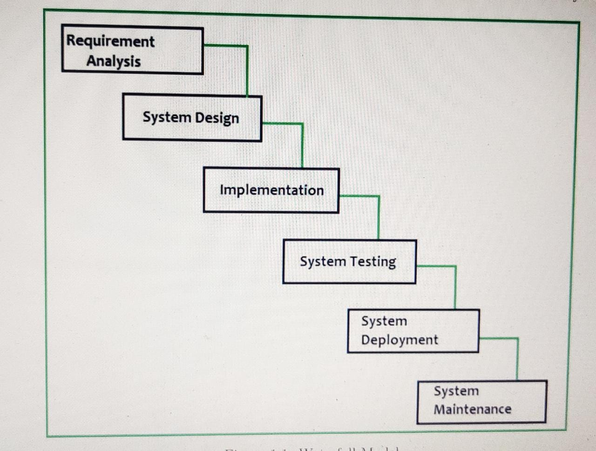

Fig 1.1 Waterfall Model

**Organization of Report**

The report is described in following way.

Chapter 1 titled Introduction, describes Background, Motivation, Problem definition, Scope and Objective, selection of life cycle model for development, organization of report and summary

. Chapter 2 titled Project planning and Management, which presents Proposed system and Feasibility study, Risk analysis, Project scheduling, Effort alloca Cost estimationand summary.

Chapter 3 titled System Analysis, which presents Software Hardware, Functional, Non-Functional requirements and Software requirement specification and summary Chapter 4 titled System design presents System Architecture, Data flow diagram and UML diagrams

. Chapter 5 titled conclusion and future work

**Summary**

In this Chapter, an Introduction along with purpose of project, scope and objectives a discussed. In the next chapter we will discuss about Feasibility study Risk Analysis Project Scheduling, Effort Allocation, Cost Estimation

**chapter 2. Project Planning and Management**

* **Feasibility Study**

Feasibility study is a test of system proposal regarding its workability, impact on the organization, ability to meet user needs and effective use of resources. Feasibility study is the initial study of the project. The feasibility study meant gathering all the information related to the project. Study the project at initial level.

This project has been tested in the following areas of feasibility

* Operation Feasibility
* Technical Feasibility
* Economic Feasibility

**Operational Feasibility**: It was decided that the proposed system could be created as a mobile based system that be operated by all the clients.

The system is designed in such a way that it is easy to operate.

The system does not involve any complex operations. It handles only simple data oriented functions.

It is aimed at giving an easy way to generate reports.

The functional accessibility is also structured in such a way it won’t take much time for anyone to get accustomed with the system.

The Client must have only the basic knowledge of mobile applications. Hence there is no need of any special person with any particular qualification or expertise in any filed to use the travels and tours system.

**Technical Feasibility**:

The system has very simple structure and easy to understand body. Also software used to build the system is simple enough in their usage and functionality.

To operate this system only a Mobile is needed. The system is platform independent system. The system can be expanded if so decided. This system is technically more secure.

**Economic Feasibility**:

An evaluation of development cost weighted against the ultimate income or benefit derived from the proposed system. Cost/benefits analysis is the most commonly used procedure for this feasibility where benefits and savings are determined that are expected from the proposed system. It is help to increase the profit and also improve the quality of service thus this system is more economical and more beneficial for the organization.

* **Risk Analysis**

Tourism and travel have always been associated with certain risks, especially in the old days when travel was filled with different types of dangers and hardships. Today's problems are ignoring related to the individual traveler, to society (with sustainable infrastructure for the trip), and last but not least to the travel industry which has developed since the end of W.W.II But there is a third party, the company which arranges or sells the trip, which is also interested in questions dealing with risk. This paper will discuss ideas, strategies and methods in establishing a research center in risk management in tourism and travel business.

* **Project Scheduling**

Project scheduling is a mechanism to communicate what tasks need to get done and which organizational resources will be allocated to complete those tasks in what time frame. A project schedule is a document collecting all the work needed to deliver the project on time.

A project is made up of many tasks, and each task is given a start and end (or due date), so it can be completed on time. Likewise, people have different schedules, and their availability and vacation or leave dates need to be documented in order to successfully plan those tasks.

The project schedule is the tool that communicates what work needs to be performed. which resources of the organization will perform the work and the time frames in which that work needs to be performed. The project schedule should reflect all of the work associated with delivering the project on time. Without a full and complete schedule, the project manager will be unable to communicate the complete effort, in terms of cost and resources, necessary to deliver the project.

For example, in cost tools have task lists, which enable the manager to schedule multiple tasks, their due dates, sometimes the planned effort against that task, and then assign that task to a person. The software might also have resource scheduling, basically the ability to schedule the team's availability, but also the availability of non-human resources like machines or buildings or meeting rooms.

Because projects have so many moving parts and are frequently changing project scheduling software automatically updates tasks that are dependent on one another, when one scheduled task is not completed on time. It also generates automated email alerts, so team members know when their scheduled tasks are due or overdue, and to let the manager know when someone's availability has changed.

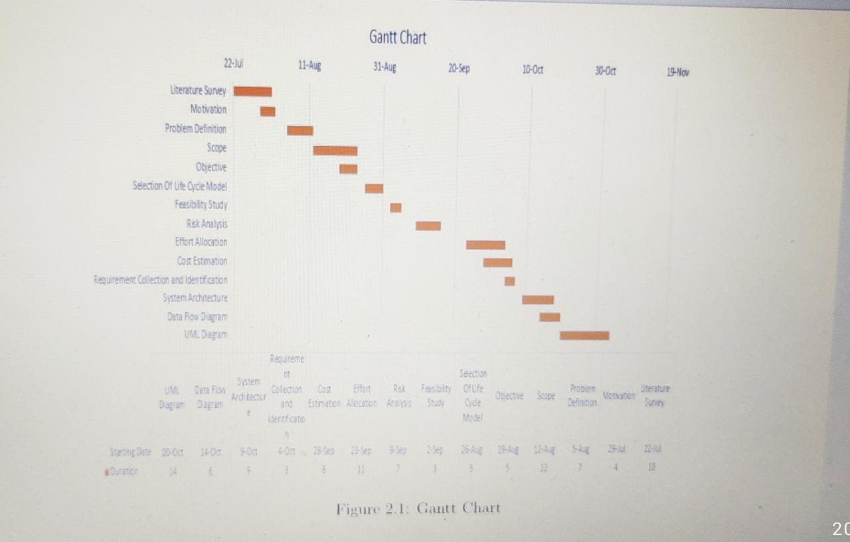

* **Effort Allocation**

Effort management refers to the effective and efficient allocation of time and resources to perform activities. These activities are generally performed in line with a strategy and a project. Effective effort management requires self-discipline, communication, motivation, energy and focus.

As part of the effort management process, effective scheduling and recording of the per formed activities is essential Depending on the results of the activity, adjustments can be made to further benefit the project and these adjustments will generally be made in the areas of quantity, quality and direction. The main goal of elfort management within organizations is to increase viable and beneficial opportunities.

Table 2.1 Effort Estimated of Following

**Chapter 3. Analysis**

* **Requirement Collection and Identification**

These system requirements are often used as a guideline as opposed to an absolute rule. Most software defines two sets of system requirements: minimum and recommended. The minimum system requirements need to be met for the software to run at all on your system, and the recommended system requirements, if met, will offer better software usability.

* **Software Requirements Specification (SRS)**

**Product Features**

The Travel Packages will be presented based on the interest of the tourist.

Easy to handle.

Save Time.

**Operating Environment**

Android is mobile operating system based on Linux kernel and developed by Google. Android is designed primarily for touch Screen mobile devices such as Smartphone’s and tablet computers. Android source code is open source licenses. Android is the most widely used mobile operating system. In our application, front end is made by android.

**Assumptions**

This mobile travel guide application available is limited to the recent operating system versions. For instance, the application is available on smartphones with the recent Android operating system. However, this application is new, the data of museums which we corporated in application may need more time to upgrade.

**Functional Requirements**

Functional requirements show the operation and activities the system must be able to perform.

1. should be able to rate tourism places after visiting their App or surfing through the information
2. should be able to search through the database either by name or state
3. shall be updated about new of tours packages.

**Non-Functional Requirements**

1. should be developed to be simple and efficient for the end users and also should be easy to understand
2. shall be able minimize the rate of errors generated by users
3. shall be compatible to any hardware
4. should be able to upgrade without disturbance to the service

**External Interfaces (User, Hardware, Software, Communication)**

**Software Requirements**:-

Windows 10 Pro

Android Studio 3.6.2

JAVA development kit 8

Database: Google’s Firestore

**Hardware Requirements:-**

Intel i3 processor

RAM 4GB

Storage 10GB

Android device(Android version 4.0 or higher)

**Chapter 4. Design**

**➢ System Architecture**

The use case is “a methodology used in system analysis to identify, clarify, and organize system requirements”. Based on the requirement analysis, a use case diagram was built as Figure 1 shows below. Since the application is used for both internal access and external access, the diagram illustrates different access rights of different user groups and provides all of the possible function of the application from user and administrator points of view. There are two groups of users, user and administrator. Moreover, according to the application character, there are four aspects of functionalities which are Tour Packages, Hotel Details , bookings and enquiries.

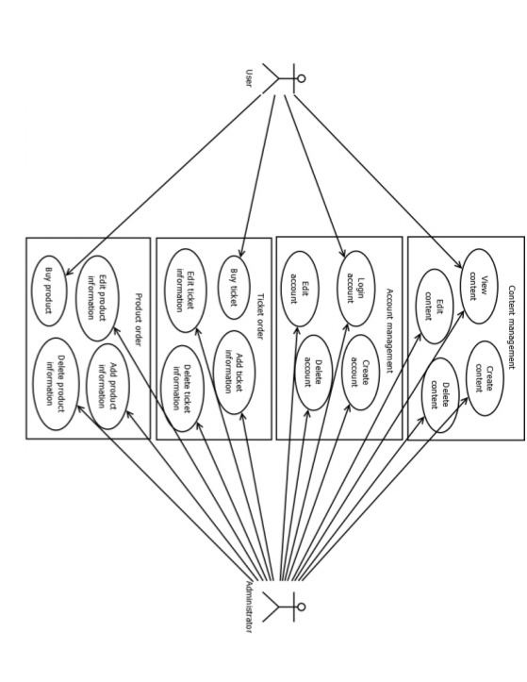

**Figure 3. Use case diagram**

The first functionality is Tour Packages. “A Tour Packages is a system used to manage the content of a App”. All data and information are created, deleted and maintained here. However, only the administrator has right to do these operations. Once there is content added ,view, the old content. The user is only able to view the content. The second functionality is Hotel Details. There are two kinds of view Hotel Details, user can view Hotel Details. The user needs to register an account with an email address and set a password first and then login. Besides, the user does not have any other access rights. The administrator has full access to operate every function, i.e. he is able to login, create, edit and delete accounts. Normally, the administrator will not delete any account.

The third functionality is bookings. With this function, admin can view the user of booked ticked or rooms ticket. If the user buys several tickets, the system will calculate the total price automatically. The user is pay on net banking, Through UPI user chooses what way to pay payment. On the other hand, the administrator is view all bookings.

The forth functionality is the enquiries. This function provides a create enquiries, view enquiries. It is similar to the ticket order. The administrator has access right to add and delete product information. User only view all these things.

**Administration**:-

The administration is the backend and it is a private operation. The responsibility is to manage user accounts and content data. The data is used for different functions’ information display. To ensure the security of the system, the username and password are necessary when the administrator logs in. Every function of administration structure is simple to use, even for people who do not have IT background.

There are the following models in administration:

**Administrator login model**

**View Tour Packages and add packages and delete**

**View Hotel Details/add hotels and delete**

**View Enquiries**

**User:-**

User firstly, log in the Appalachian, User is the frontend and it is public operation. User can view all packages of tours, and also view all hotel details .User filled the enquiry form and book the ticket.

There are the following models in User:

**Log In /Registration**

**View All Packages**

**View All Hotels**

**Book Package**

**➢ Data Flow Diagram**

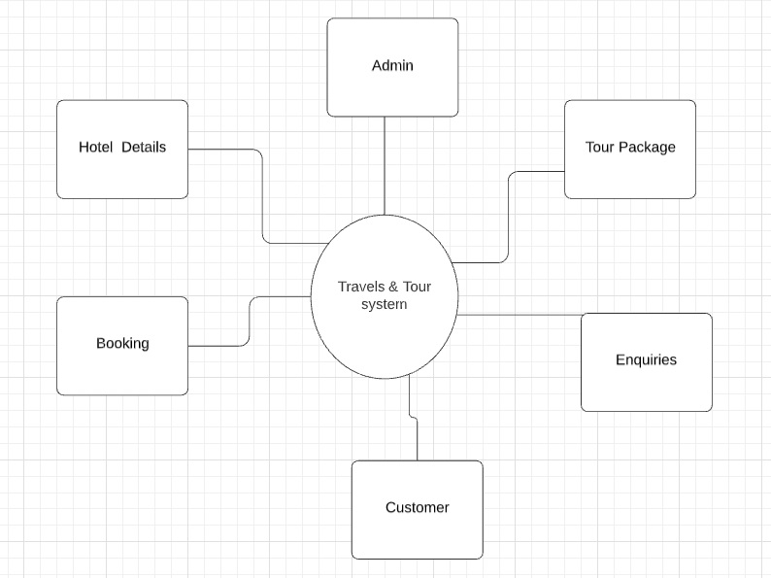

**Fig.2 Data Flow Diagram**

**➢ UML Diagrams :-**

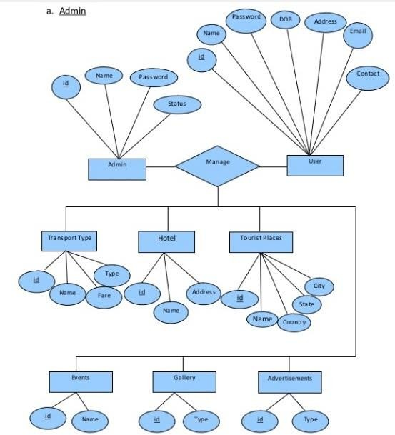

**Fig. Data Flow Diagram**

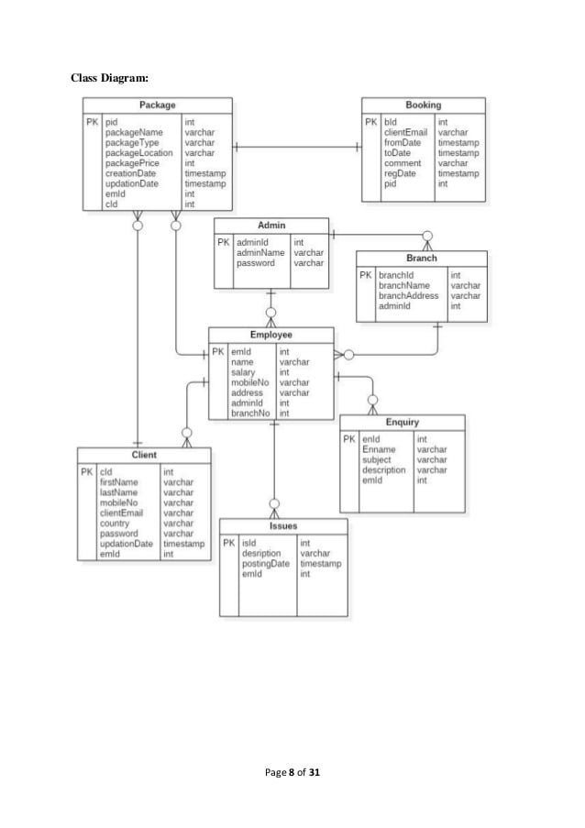

**Fig. Class Diagram**

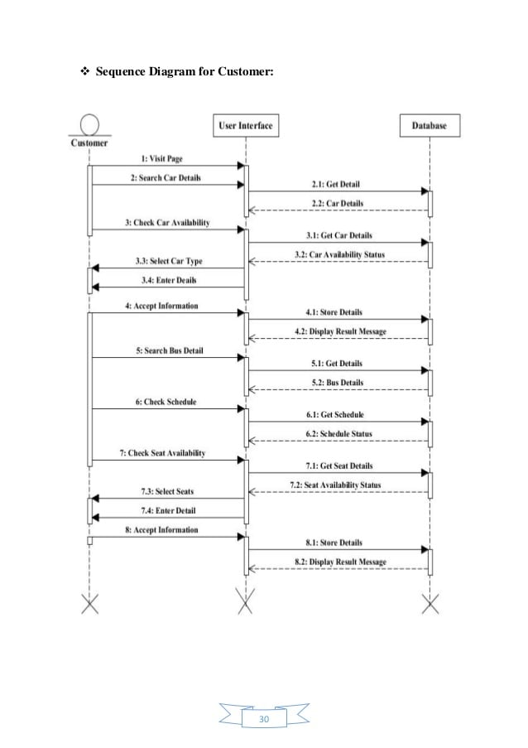

**Fig. Sequence Diagram**

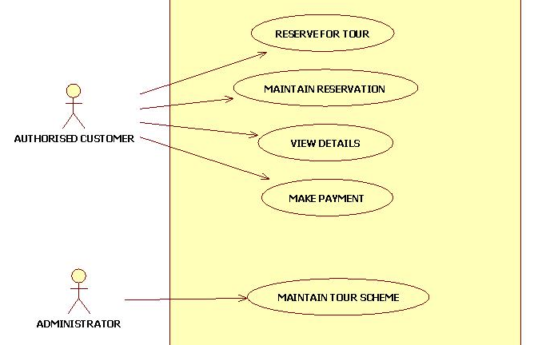

**Fig. Use Case Diagram**

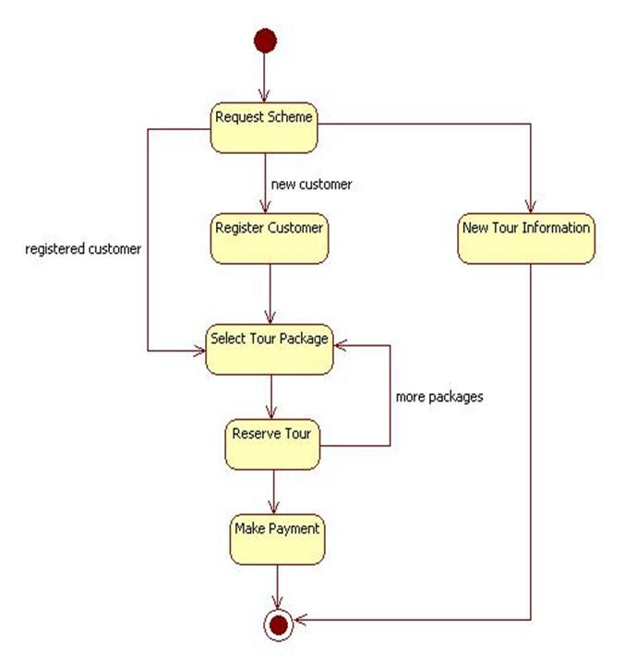

**Fig. State Chart Diagram**

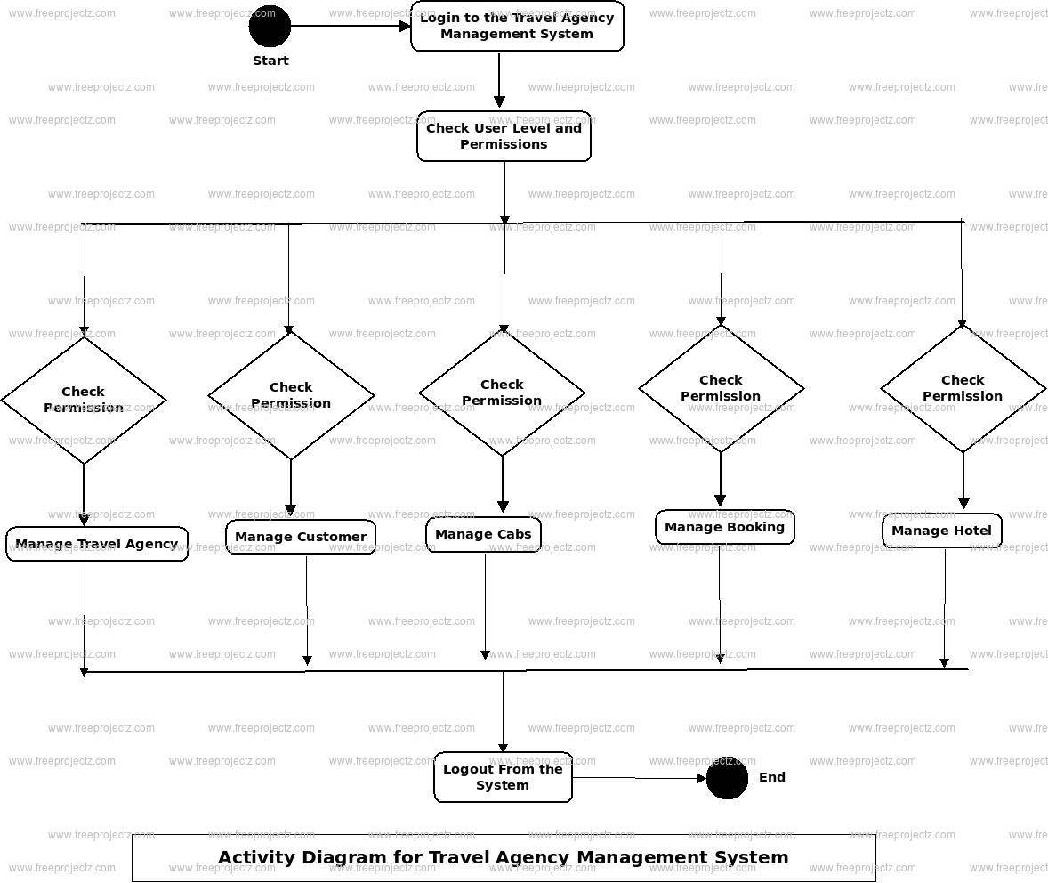

**Fig. Activity Diagram**

**Chapter 6. Firebase Database**

**7.1 Introduction**:-

Firebase is a mobile and web application development platform developed by Firebase, Inc. in 2011, then acquired by Google in 2014. As of March 2020, the Firebase platform has 19 products, which are used by more than 1.5 million apps. Firebase evolved from Envolve, a prior startup founded by James Tamplin and Andrew Lee in 2011. Envolve provided developers an API that enables the integration of online chat functionality into their websites. After releasing the chat service, Tamplin and Lee found that it was being used to pass application data that were not chat messages. Developers were using Envolve to sync application data such as game state in real time across their users. Tamplin and Lee decided to separate the chat system and the real-time architecture that powered it. They founded Firebase as a separate company in September 2011 and it launched to the public in April 2012.

Firebase's first product was the Firebase Real-time Database, an API that synchronizes application data across iOS, Android, and Web devices, and stores it on Firebase's cloud. The product assists software developers in building real-time, collaborative applications. In May 2012, a month after the beta launch, Firebase raised $1.1 million in seed funding from venture capitalists Flybridge Capital Partners, Greylock Partners, Founder Collective, and New Enterprise Associates. In June 2013, the company further raised $5.6 million in Series A funding from Union Square Ventures and Flybridge Capital Partners. In 2014, Firebase launched two products. Firebase Hosting and Firebase Authentication. This positioned the company as a mobile backend as a service.

In October 2014, Firebase was acquired by Google. A year later, in October 2015, Google acquired Divshot, an HTML5 web-hosting platform, to merge it with the Firebase team. In May 2016, at Google I/O, the company's annual developer conference, Firebase introduced Firebase Analytics and announced that it was expanding its services to become a unified backend-as-a-service (BaaS) platform for mobile developers. Firebase now integrates with various other Google services, including Google Cloud Platform, AdMob, and Google Ads to offer broader products and scale for developers. Google Cloud Messaging, the Google service to send push notifications to Android devices, was superseded by a Firebase product, Firebase Cloud Messaging, which added the functionality to deliver push notifications to both iOS and web devices. In January 2017, Google acquired Fabric and Crashanlytics from Twitte to add those services to Firebase.

In October 2017, Firebase has launched Cloud Firestore, a real-time document database as the successor product to the original Firebase Realtime Database.

**Chapter 6. Testing**

**➢White Box testing**

White-box testing is called as glass-box testing. It is a test case design method that uses that control structure of the procedural design to derive test cases.

• It is known as glass box testing.

• It uses control structure to design the test cases.

• White box testing removes general errors.

• Assures that every independent path present in the module is executed at least single time.

• All logical decisions are exercised to its true as well as false condition.

• Loops need to be executed within its boundaries and the boundaries of operation.

• Execute or implement internal data structures to make sure its validity. White-box testing is performed early in the testing process and the black box testing tends to be applied during later stages testing

* **Manual Testing**

Manual testing is a software testing process in which test cases are executed manually without using any automated tool. All test cases are executed manually according to the end user's perspective.

1. Testing of package booking module- In this module as described first source, destination in text form and date of journey to be it is tested by performing the action as described and the test is successful as the input is properly accepted by the system and by clicking on Book Now the booking process successfully Further next page as expected details are to be entered which are also successfully accepted in text form as expected and also total amount of booked seats is successfully calculated directed by choosing the Pay process after selecting payment process is successfully then finial package is book.
2. Tasting of Hotel booking module- In this module also first source date of journey inputs should be provided and while testing it is observed that these inputs are properly taken by system, then fill the other details like Guest Name,Total Guest in between Adults and Children, Email idand contract details after that Adress and city and while testing it is observed that these input are properly taken by system.Then for Futher process click on Book Now and while testing it is observed that these inputs are properly take by system. which are also successfully accepted in text form as expected and also total amount of booked hotel is successfully calculated directed by choosing the Pay process after selecting payment process is successfully then finial hotel is book.

**Chapter 7. Output**

**➢ Test Cases Identification and Execution (Test case ID, Input, Output, Expected Output, Actual Output, Result (Pass/Fail) etc.)**

**User App Screen Shots :-**

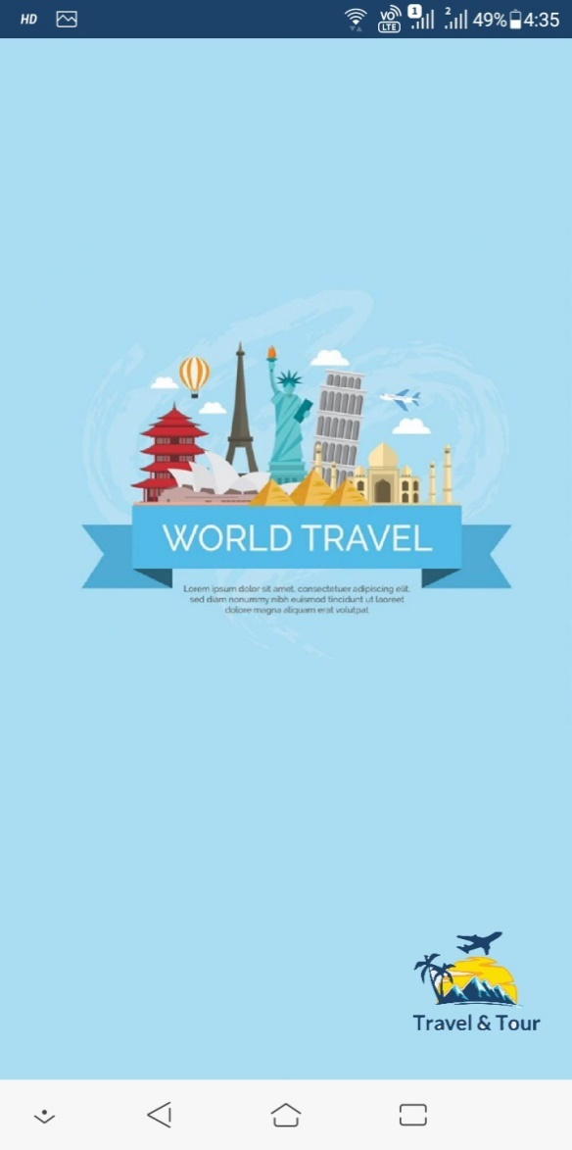 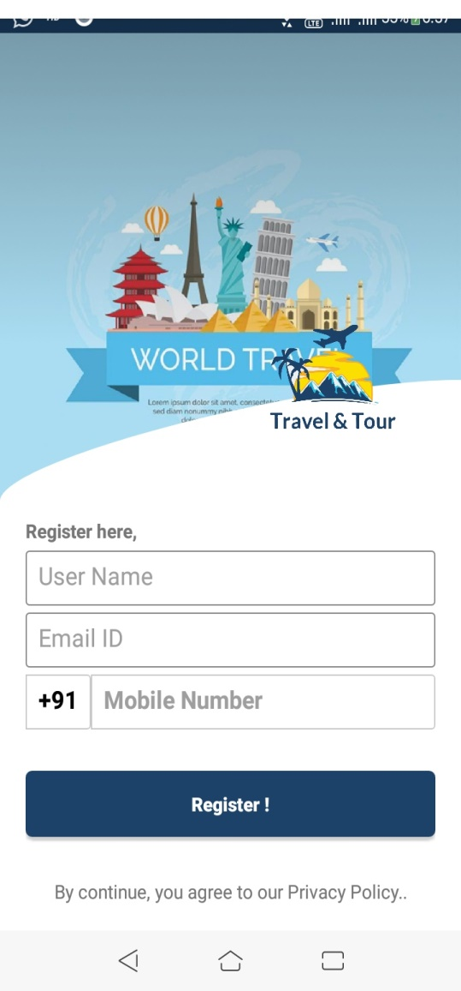

Fig. Flash Activity Fig. Registration Activity

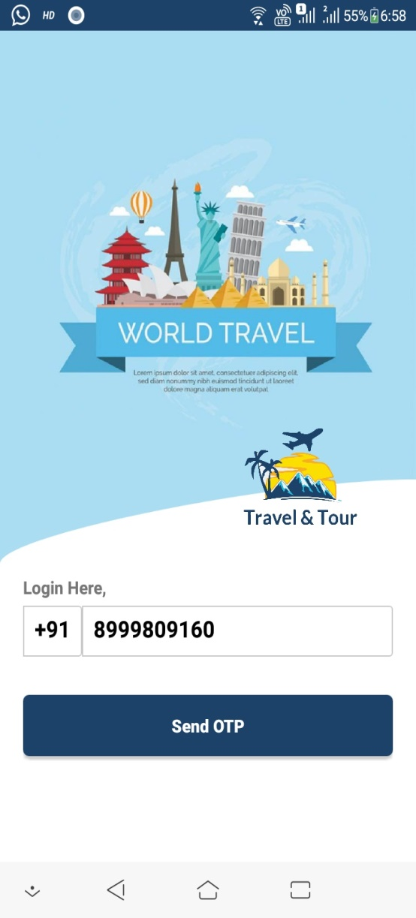 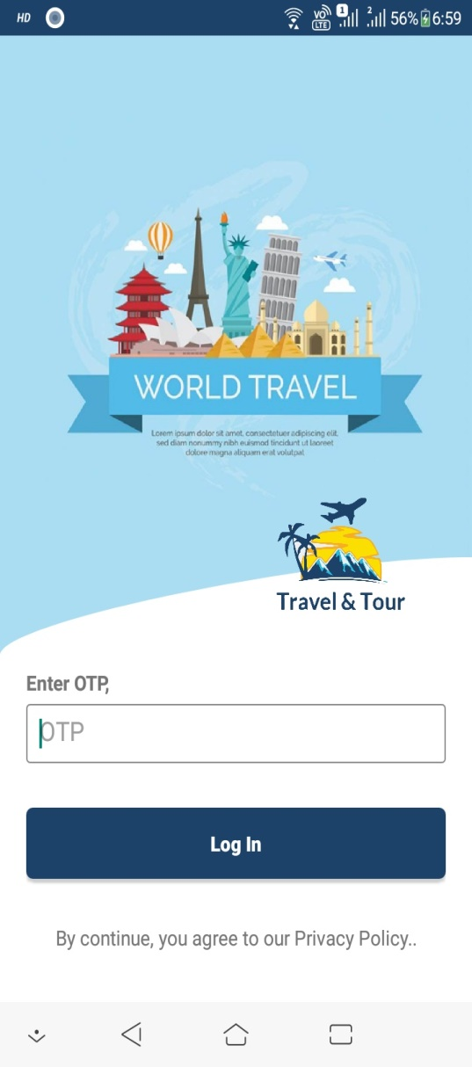

Fig. Login Activity Fig. Enter OTP

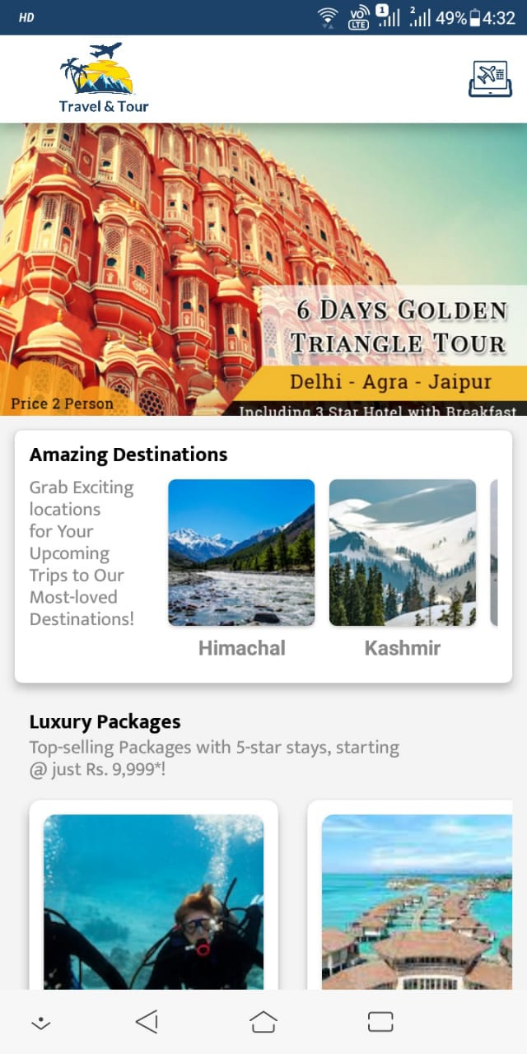 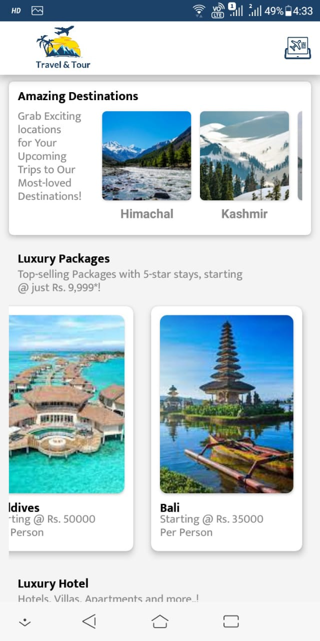

Fig. Packages Fig. Hotel Details

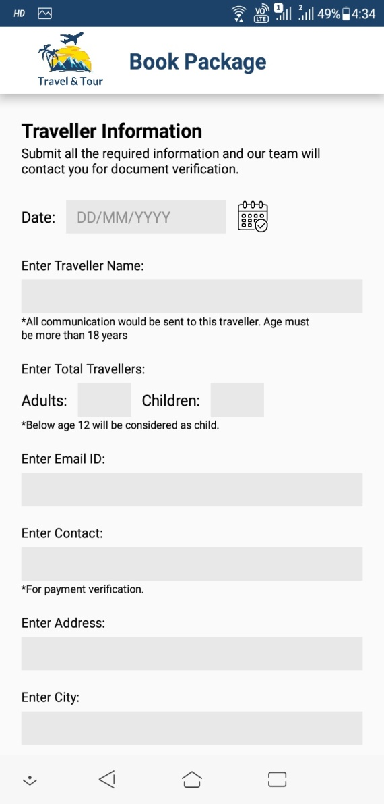 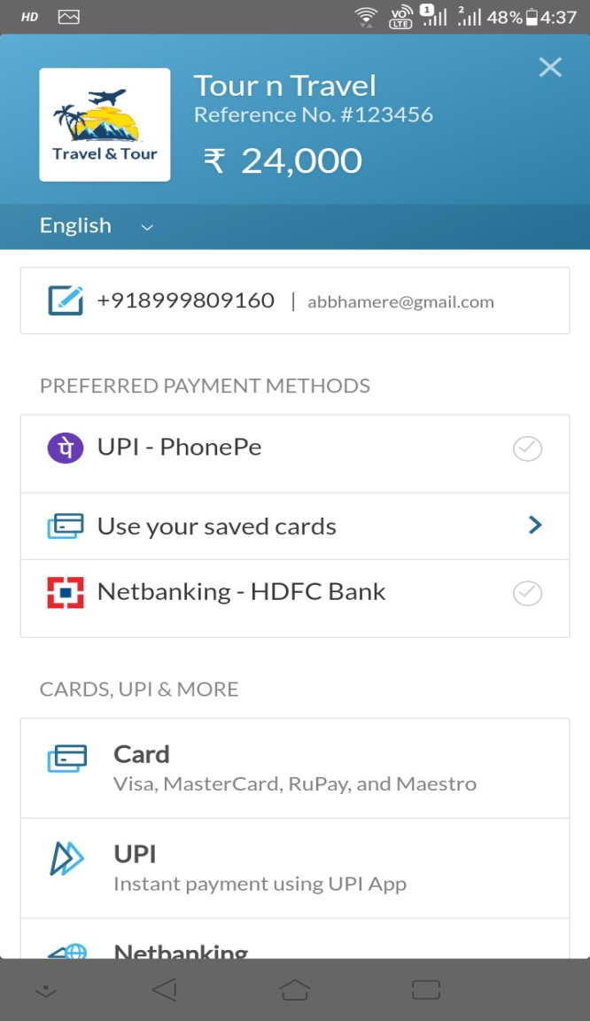

Fig. Booking Package Fig. payment

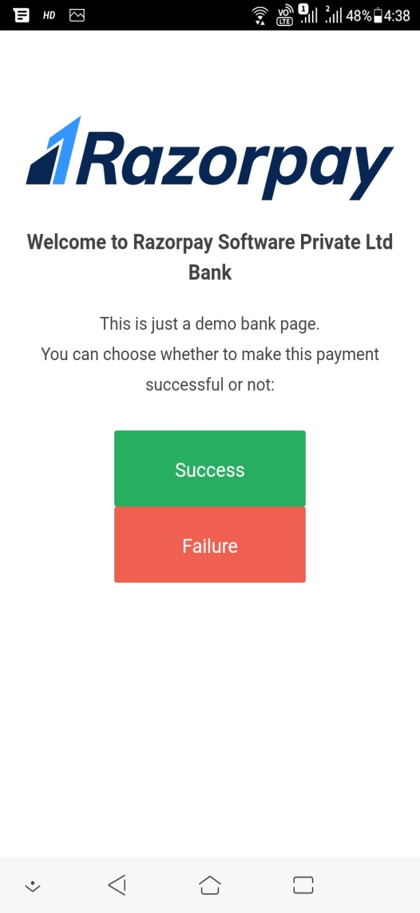 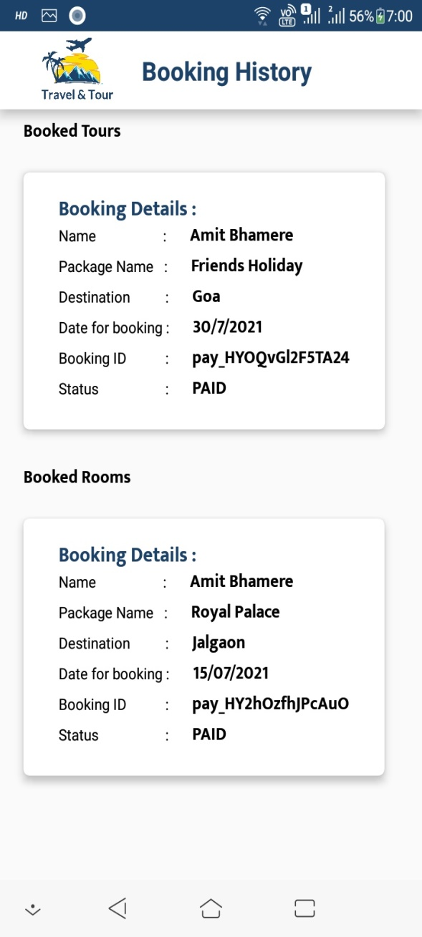

Fig. Payment Fig. History

**Admin App ScreenShot:-**

 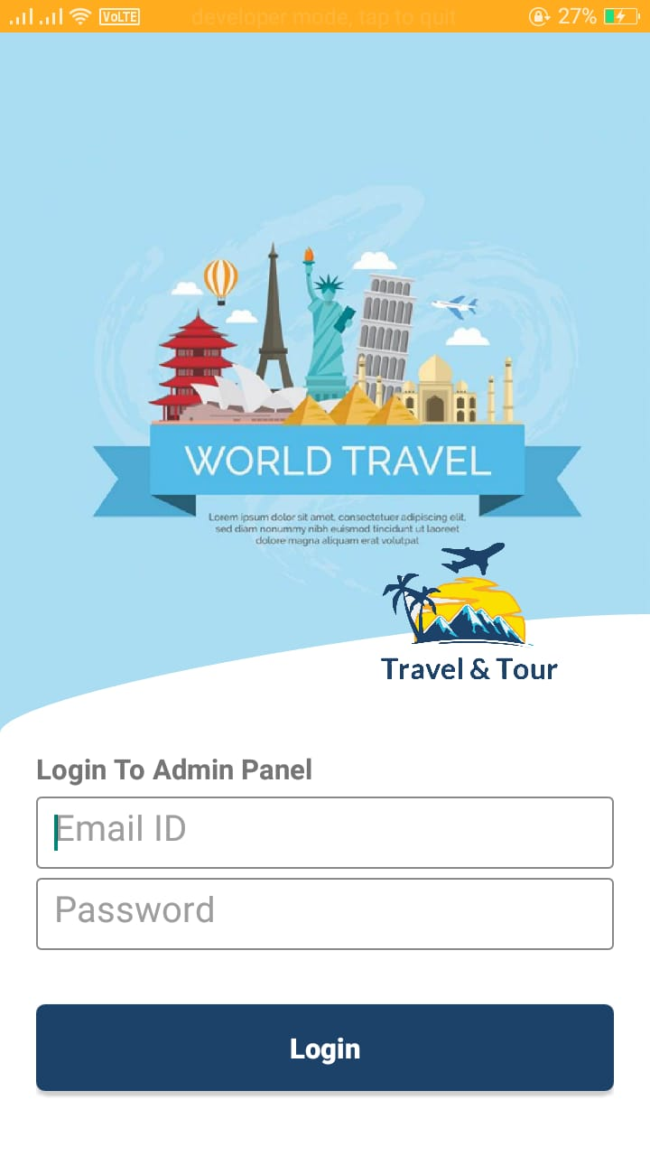

**Fig. Flash Activity Fig. Login Activity**

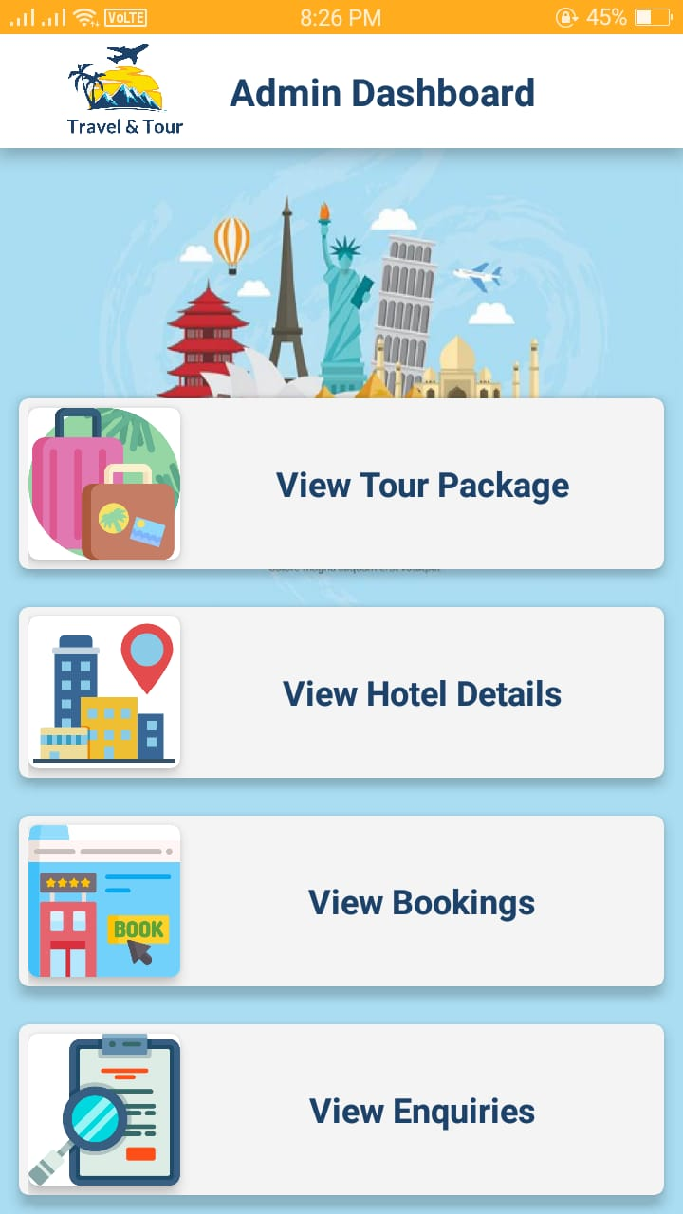 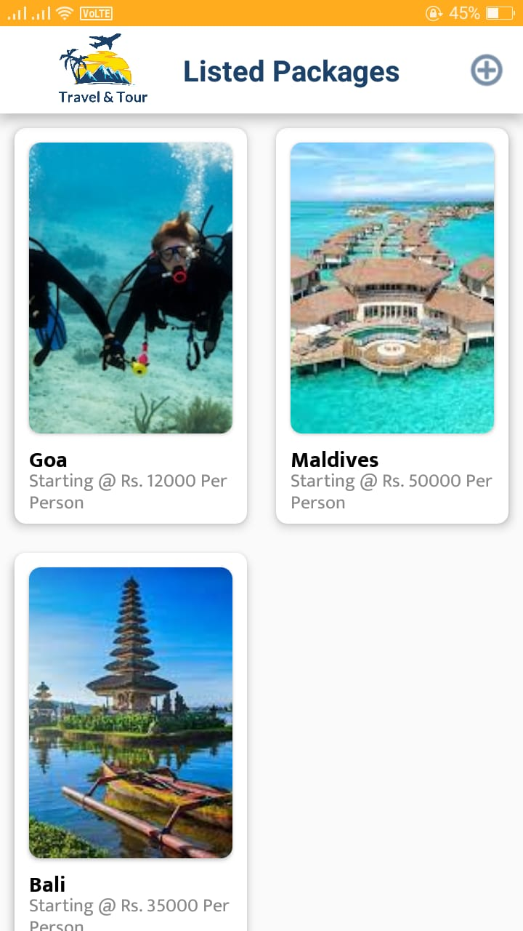

**Fig. Dashboard Activity Fig. Package Activity**

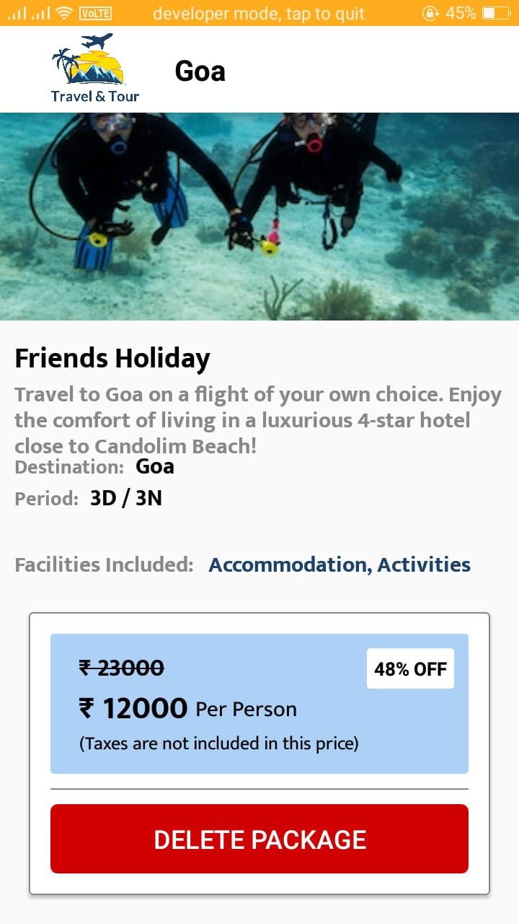 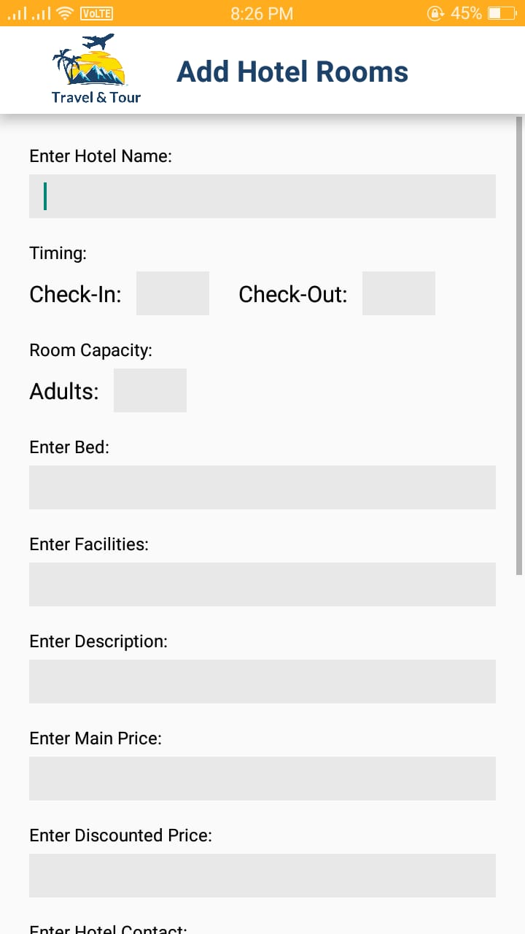

**Fig. Package Fig. Add Hotel Rooms**

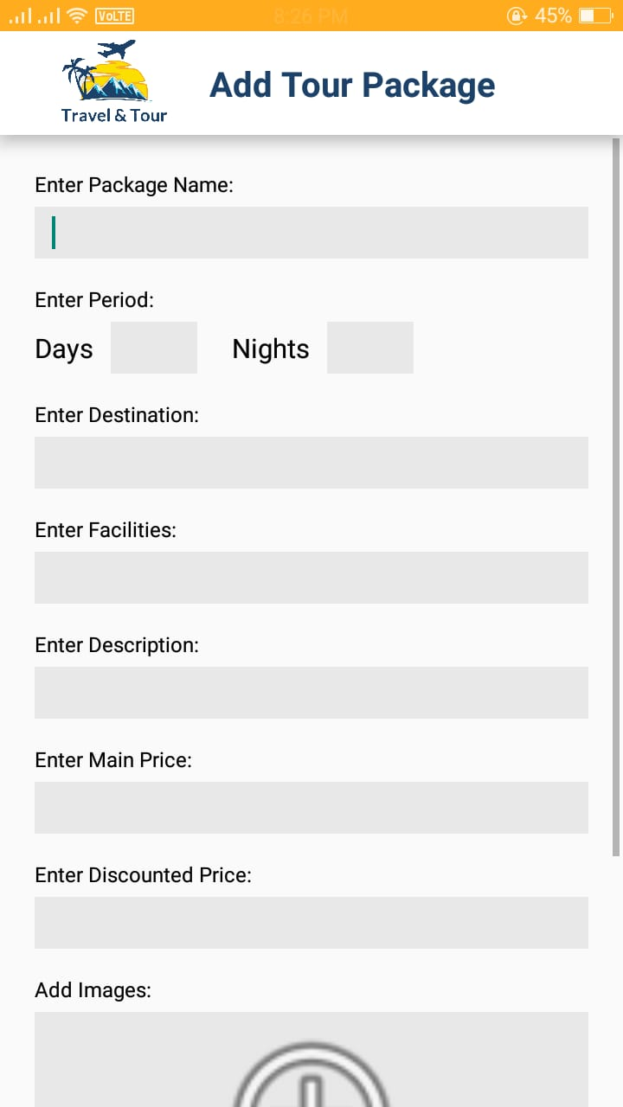 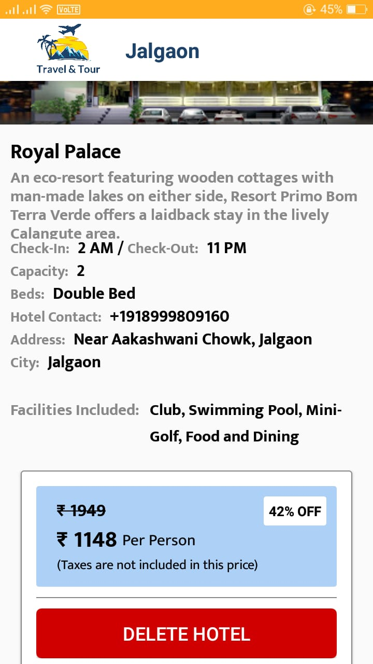

**Fig. Add Package Fig. Delete Hotel**

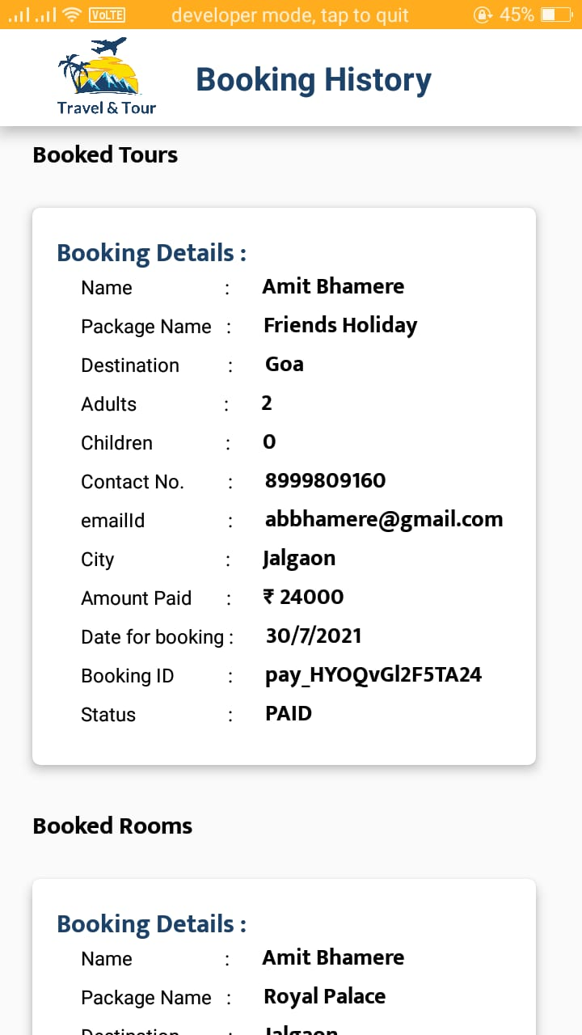

**Fig. Booking History**

**8. Conclusion**

It has been a great pleasure for me to work on this exciting and challenging project. This project proved good for me as it provided practical knowledge of not only programming in JAVA and Mobile based application. It also provides knowledge about the latest technology used in developing App enabled application that will be great demand in now days.

**Future Work:-**

* Now a days everyone use a Smartphone.
* Design the user interface using an iterative, audience-involved process to ensure optimal usability within the target audience.
* Create efficient and easily extensible data structures within the application to allow for simple updates to the information it presents.
* Develop a set of image-processing algorithms that can classify photographs.

**Bibliography**

1. Hala Almaimoni, "Developing and Implementing WEB-based Online Destination In formation Management System for Tourism", International Journal of Applied Engi neering Research ISSN 0973-4562 Volume 13, Number 10 (2018) pp. 7541-7550

2. Saced Q Y Al-Khalidi and 2Prakash Kuppuswamy, "IMPLEMENTATION OF NEW ICT STRUCTURE IN E-TOURISM INDUSTRY: SAMPLE APPROACH IN KING DOM OF SAUDI ARABIA", International Journal of Current Research Vol. 6, Issue, 02, pp.5009-5012, February, 2014

3. Deepthi Shanker, "ICT and Tourism: Challenges and Opportunities". Humanities and Social Sciences, Indian Institute of Technology, Conference on Tourism in India Challenges Ahead, IIMK, India15-17 May 2008 Dimitrios Buhalis, Maria Cristina Licata, The Future eTourism intermediaries". ENTER2001 conference in Montreal, Canada, 2001. Essawy, M., Testing the Usability of Hotel Websites The Springboard for Customer Relationship Building, Leeds, 2005. Garín-Muñoz, Teresa; Pérez-Amaral. Teodosio, "Internet Usage for Travel and Tourism The Case of Spain", 21st European Regional ITS Conference, Copenhagen 2010 Gursoy, D., and McCleary, K., "An inte grative model of tourism information search behaviour", Annals of Tourism Research, Vol 31 No 2. 353-373, 2004

4.www.MakeMyTri.com

5.www.Goibibo.com

**Index**

Porter, 2

Feasibility, 8

Database management, 16